Crumble pie with apples
3 dl wheat flour
150 grams of butter
1 ½ dl sugar
1 ½ tbspn potato flour
3-4 apples
Peel the apples and cut them into slices. Put them in a pie dish and sprinkle them with cinnamon.
Mix the dry ingredients.
Cut the butter into small pieces and add them with the rest of the ingredients.
Cover the apples with the dough and put it in the oven for about 30 minutes, 220
Degrees Celsius. The pie shall get a golden colour.

Serve with vanilla custard sauce or vanilla ice cream!

Janson’s temptation
8-10 potatoes
2 onions
20 brisling anchovy fillets
4 dl whipping cream
1 tbspn dried bread crumbs
1 tbspn butter
Peel the potatoes and onions.
Slice them into thin slices.
Alternate layers of potatoes, onion and anchovies in a lightly greased baking dish. The top and bottom layers shall consist of potatoes.
Pour the cream and 2-3 tablespoons anchovy juice over the potatoes. Dot with butter and sprinkle with bread crumbs.
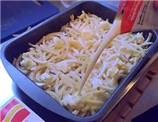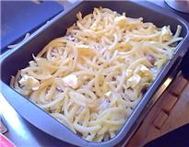
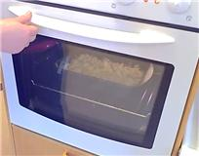
Bake in the oven, (225 degrees Celsius) for 45 minutes.
Herring salad
2 dl sour cream
½ dl mayonnaise
4 tbspn caviar
1 finely chopped red onion
1 dl finely chopped leek
½ chopped dill
1 pickled herring

3 hardboiled eggs
Mix all the ingredients (except the eggs) together.
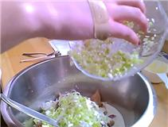
Let it sit in the fridge for a while and before you serve it, sprinkle the salad with finely chopped eggs.

Eat it together with bread.

