Toys
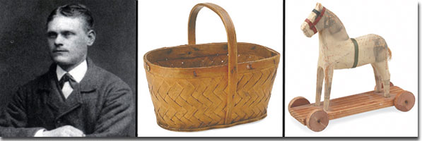

Facts about Brio:
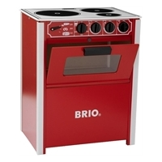
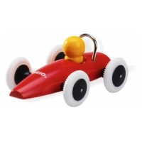
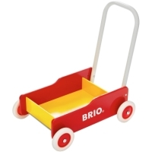
Ivar Bengtsson, 1860-1948, was the Swedish founder of the corporation Brio. Brio started in 1884 and that’s the year when Ivar Bengtsson received his first order from different places in Sweden. Since then a lot of children have enjoyed playing with the typical wooden toys made by Brio. In many families you can find at least one or two of these toys:

